Audlem Traffic Survey Summary
Produced by Road Data Services Ltd

A 7-Day Automatic Traffic Count was carried out between 12th and 18th January 2024 on A525 Shropshire Street, below are a summary of the results: -
 | 12/01/2024 | 13/01/2024 | 14/01/2024 | 15/01/2024 | 16/01/2024 | 17/01/2024 | 18/01/2024
Total Flow | Friday | Saturday | Sunday | Monday | Tuesday | Wednesday | Thursday
Southwestbound | 2595 | 1975 | 1585 | 2296 | 2342 | 2387 | 2361
Northeastbound | 2587 | 2022 | 1607 | 2317 | 2401 | 2405 | 2464
TOTAL | 5182 | 3997 | 3192 | 4613 | 4743 | 4792 | 4825

Total Flow | Weekday | Week
Southwestbound | Average | Average
Northeastbound | 2396 | 2220
TOTAL | 2435 | 2258
 | 4831 | 4478

 | Mean | 85th Percentile
Speed (mph) | Speed | Speed
Southwestbound | 17.8 | 17.9
Northeastbound | 23.0 | 23.2

A Parking survey was carried out in the following zones along with the Cheshire Street Car Park on Saturday 13th and Thursday 18th January 2024.
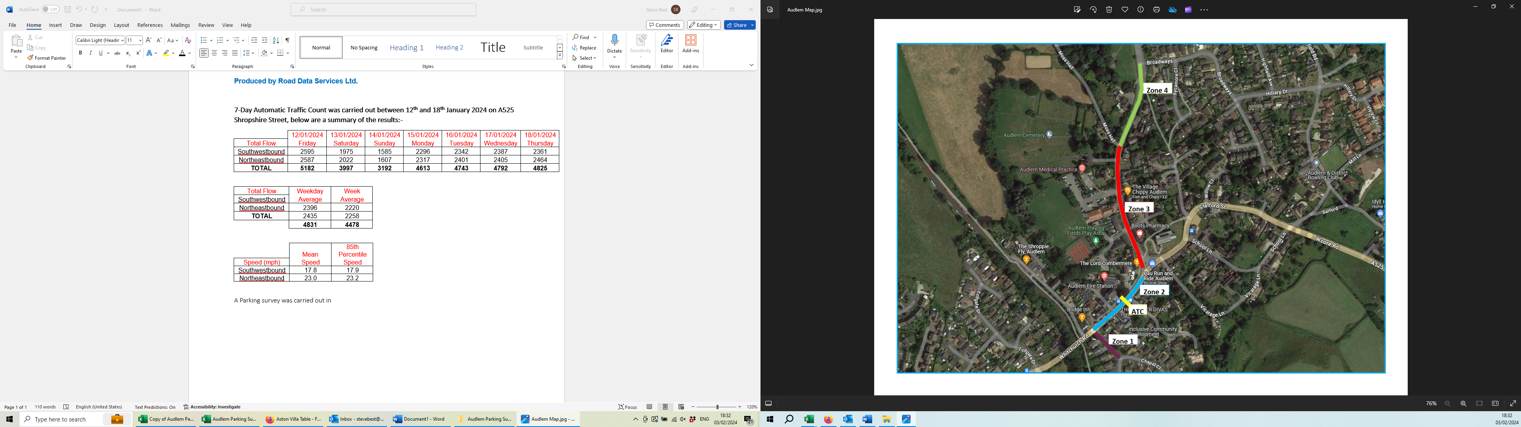
Below is a summary of the survey; please note this does not include any illegal parking. For a more detailed incite please look at the Audlem Parking Survey spreadsheet along with the maps.
Zone | Average Occupancy |  |  | Percentage Occupied
 | Spaces | Saturday | Thursday | Saturday | Thursday
1 | 5 | 2.6 | 1.92 | 52.0 | 38.4
2 Marked Bays | 11 | 8.7 | 8.5 | 79.1 | 77.3
2 Dropped Kerb | 1 | 1 | 0.25 | 100.0 | 25.0
3 Marked Bays | 10 | 6.6 | 6.3 | 66.0 | 63.0
4 No Restrictions | 17 | 4.67 | 6.42 | 27.5 | 37.8
4 Western Side | 15 | 0.5 | 0.25 | 3.3 | 1.7
Car Park marked Bays | 65 | 32.6 | 45.25 | 50.2 | 69.6

